Enterprise logo ( if any )

Enterprise Name

annual WORK REPORT
Mining license
Year 20..

Enterprise name: ___________________
Register No.: ___________________
License No.: ___________________
Owner (Manager): ___________________
Commodity type: ___________________
Business No.: ___________________
Municipality: ___________________
Region: ___________________

Date.........

Mining-mining activity

Company: xxxxxxxxxxxxxxx
Register No.:xxxx
License No.:xxxx

Description of the works carried out during mining process
Activity type | Description of activity
Discovery:
Stacking:
Loading:
Drilling Blasting:
Transport:
Processing (Separation, Enrichment):
Dewatering works:
Changes from the mining project:
Confirm license area is marked:
Systematic medical examinations:
Workers training:
Add row as needed:

Data on accidents during mining activity
Nature of injury | No. | Brief description of the accident
Collective injuries:
Serious injuries:
Minor injuries:
Add row as needed:

Statistics of labour force divided into categories
Category | No.
Management:
Office staff:
Worker:
Driver:
Add row as needed:

Statistics of labour force divided according to qualification
Qualifications | No.
High and superior:
Secondary:
Unqualified:
Add row as needed:

Report on environmental impacts
Type of pollution (environmental impact) | Brief description
Dust:
Noise:
Water flow:
Add row as needed

At Geology report for exploited reserves, see tables: Non-metallic Minerals an Metallic Minerals With different units (Pb%, Zn%, Ag g/t, Aug/t.. etc),
Use the appropriate table for your license, whereas you delete the other tables together with this comment from the report.

GEOLOGY - STATE OF RESERVES
Year 200xx
Enterprise: ..............
Register No.............
License No.:.........
Non-metallic Minerals
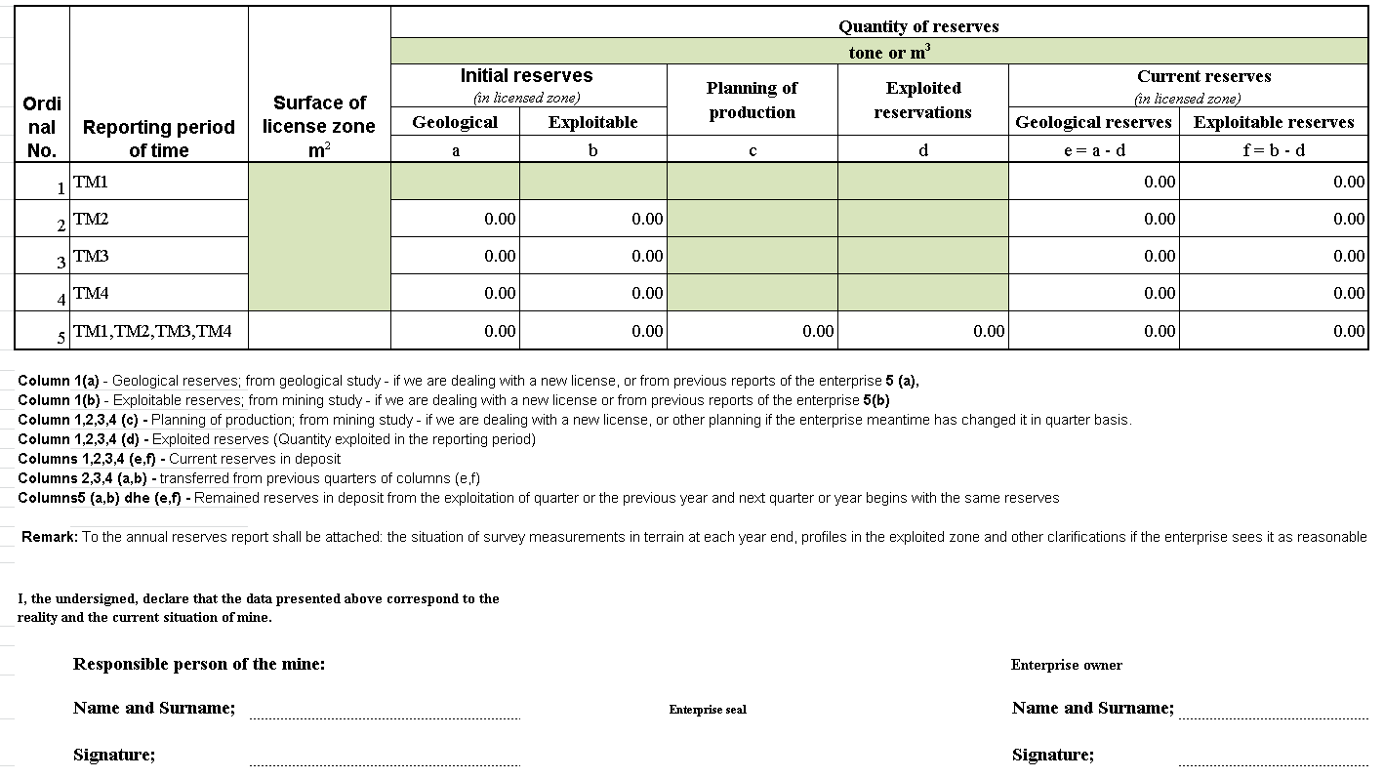

Metallic Minerals
With different units (Pb%, Zn%, Ag g/t, Aug/t.. etc)
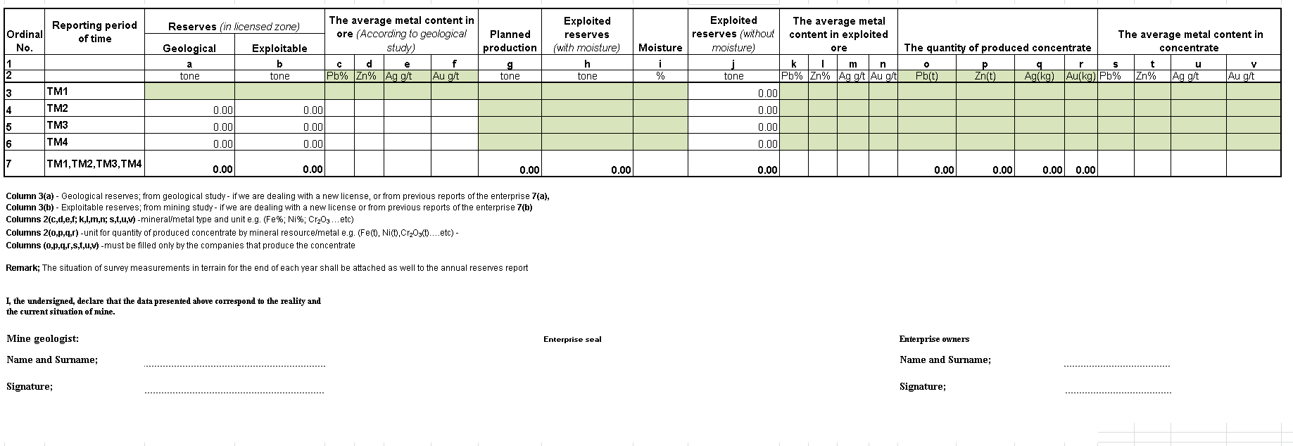

SURVEY
(Situation of Survey Measurement)
Enterprise ......................
Register No.: ..................
License No.: ....................

Contents of the report:

- License of Licensed Surveyor or of licensed Survey company (Copy)
- The original data from the terrain measurement (nr,y,x,h) in *xls format(hard copy and CD)
- Terrain situation in hard copy and CD.
- Terrain situation in digital form (*dxf)
- Report on the calculated (exploited) measures from the terrain situation in the digital form.

I, the undersigned, declare that the data presented above correspond to the reality and the current situation of mine.

Surveyor: Enterprise owner:

Name and Surname: ....................... Name and Surname:............................

Signature:................ Signature:................

Enterprise seal

FINANCE
* To be filled in by responsible person for finances
1. ENTERPRISE DETAILS:
Enterprise: |  |  |  |  | BRN: | Licence No.
 |  |  |  |  |  | Application No.
Report date |  |  |  | Business Headquarters | Mining site |  | Mineral type
Date | Month | Year
Employees number |  |  |  |  | The amount of monthly salaries |  |  | The amount of annual salaries
Main business activity |  |  | Secondary business activity |  | Other activities
If you carry out two or more activities in your business, do you keep books or specific evidence for works or mining activities for which you are licensed in ICMM No Yes

2. CAPITAL INVESTMENTS DURING THE YEAR .......
Investments shall be related with mining activity:
Description | Amount

- OPERATIVE EXPENDITURES DURING THE YEAR ........,
Investments shall be related with mining activity
Description | Amount

- ROYALTY IN €/(tone or m³)
Royalties shall be completed by the enterprise, the annual data divided quarterly for the respective year. Present the mineral type, the price of royalty and the payment done for royalty for the period you report.
Report period | Quantity in( ) | Royalty price € | Paid €
Q1
Q2
Q3
Q4
TOTALLY: Q1+Q2+Q3+Q4
Remark:
*Please attach the evidences of quarterly reports (completed, corrected and paid forms) for the year ....., this completed form will not be accepted if you do not attach evidences. If the form is not submitted on time, the administrative fines will be charge according to the Law No.03/L-163 and the Law No. 04/L-158 article 26.
*Add Table 4, depending on the number of mineral resources/metals.
*If the enterprise does not use mineralresources with fixed royalty amount, erase tab. 4 together with explanations below the table.

- PRICE OF LME STOCK EXCHANGE ON MINERAL RESOURCES ......
Month | January | February | March | April | May | June
Price in € for unit ( ) | € | € | € | € | € | €
Month | July | August | September | October | November | December
Price in € for unit ( ) | € | € | € | € | € | €
Remark:

- ROYALTY FOR MINERAL RESOURCES / METAL ......
It shall be completed by the enterprise, the annual data divided quarterly for the respective year. Present the mineral type, the price used to calculate royalty and the price of LME stock exchange, payment done for royalty for the period you report.
Report period | Quantity in( ) | Royalty amount for payment € | Paid  €
Q1
Q2
Q3
Q4
TOTALLY: Q1+Q+Q3+Q4

*Please attach the evidences of quarterly reports (completed, corrected and paid forms) for the year ....., this completed form will not be accepted if you do not attach evidences. If the form is not submitted on time, the administrative fines will be charge according to the Law No.03/L-163 and the Law No. 04/L-158 article 26.
*Add table 4 and 5, depending on the number of mineral resources/metals.
*If the enterprise does not use mineral resources with royalty with %, erase tab. 5,6 together with explanations below the table.

- CONTRACTS AND TRANSACTIONS WITH OTHER COMPANIES
Contract Description | Mineral Type | Quantity ( ) | Period
TOTALLY
* To be filled in by all enterprises that posses Licenses and Special Operations Permits.
**Add table 5, depending on the number of mineral resources/metals.

- TAXES AND ADMINISTRATIVE FEES
Taxes paid during year ….. | Q1 | Q2 | Q3 | Q4
Tax profit:
VAT:
Other taxes (ICMM):
TOTALLY:

- PLANNING OF SELLING THE MINERALS DETERMINED FOR THE YEAR ......
Mineral Description | Quantity in m³/ton | Sale (Market) price | Period

REMARK: The form shall be completed based on the Law No.03/L-163, Special Permit and License Rights and Obligations, article 34. Please attach the evidences of quarterly reports (completed, corrected and paid forms) for the year 2014, this completed form will not be accepted if you do not attach evidences. If the form will not be submitted on time, the administrative fines will be charged according to the Law No.03/L-163. If you have more than one License or Permit, the special form shall be completed for each number of License or Permit.

- REPORT OF INDEPENDENT AUDITOR

REMARK 2: Submission of financial statement shall be audited by the independent auditor according to the Law No. 03/L-163 article 34 paragraph 4.2.3 and 4.2.4. and the Law No. 04/L-158 article 26 on amending and Supplementing the Law No. 03/L-163 on Mines and Minerals
4.2.3 an audited annual statement showing the amount of the royalty that has been determined to be payable in respect of such calendar year, together with all information and calculations relating thereto and any modifications and explanations required to reconcile such annual statement with statements previously submitted in accordance with paragraph 4 subparagraph 4.1 point 4.1.1 of this article and
4.2.4.an audited annual financial report showing the profit or loss and the state of the financial affairs of the Licensee at the end of such calendar year.

I hereby declare with full responsibility that the information offered in this report are true, complete and can be verified in any time.

Name/Surname /Signature and Stamp dd/mm/yy

__________________________ ___/____ /_______

