Enterprise logo ( if any )

Enterprise Name

QUARTERLY WORK REPORT
Mining license
Year 20..

Report period
......... - ....... (Q...)

Enterprise name: ___________________
Register No.: ___________________
License No.: ___________________
Owner (Manager): ___________________
Commodity type: ___________________
Business No.: ___________________
Municipality: ___________________
Region: ___________________

Date:.........

Mining-mining activity

Company: xxxxxxxx
Register No.:xxxx
License No.:xxxx

Description of the works carried out during mining process
Activity type | Description of activity
Discovery:
Stacking:
Loading:
Drilling Blasting:
Transport:
Processing (Separation, Enrichment):
Dewatering works:
Changes from the mining project:
Confirm license area is marked:
Systematic medical examinations:
Workers training:
Add row as needed:

Data on accidents during mining activity
Nature of injury | No. | Brief description of the accident
Collective injuries:
Serious injuries:
Minor injuries:
Add row as needed:

Statistics of labour force divided into categories
Category | No.
Management:
Office staff:
Worker:
Driver:
Add row as needed:

Statistics of labour force divided according to qualification
Qualifications | No.
High and superior:
Secondary:
Unqualified:
Add row as needed:

Report on environmental impacts
Type of pollution (environmental impact) | Brief description
Dust:
Noise:
Water flow:
Add row as needed

At Geology report for exploited reserves, see tables: Non-metallic Minerals an Metallic Minerals With different units (Pb%, Zn%, Ag g/t, Aug/t.. etc),
Use the appropriate table for your license, whereas you delete the other tables together with this comment from the report.

GEOLOGY - STATE OF RESERVES
Year 20...
Company: ...............
Register No.:............
License No.:.........
Non-metallic Minerals
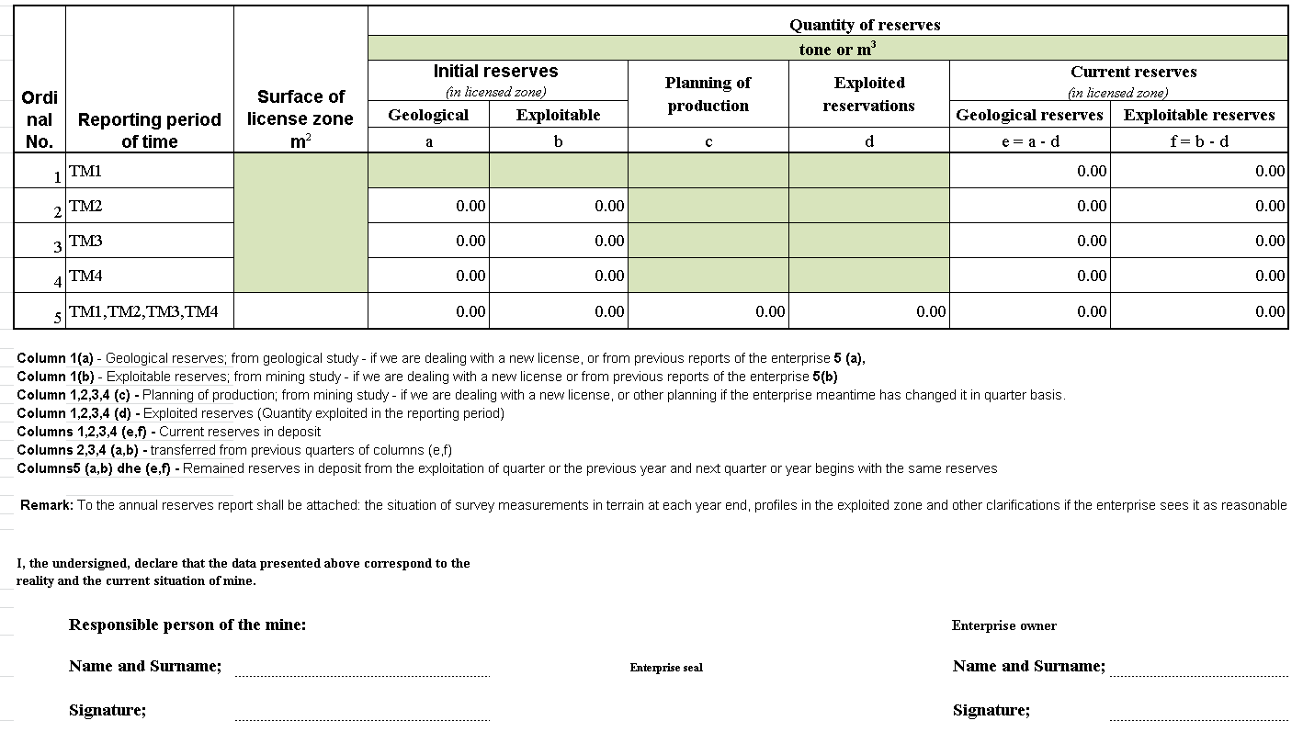

Metallic Minerals
With different units (Pb%, Zn%, Ag g/t, Aug/t.. etc)-
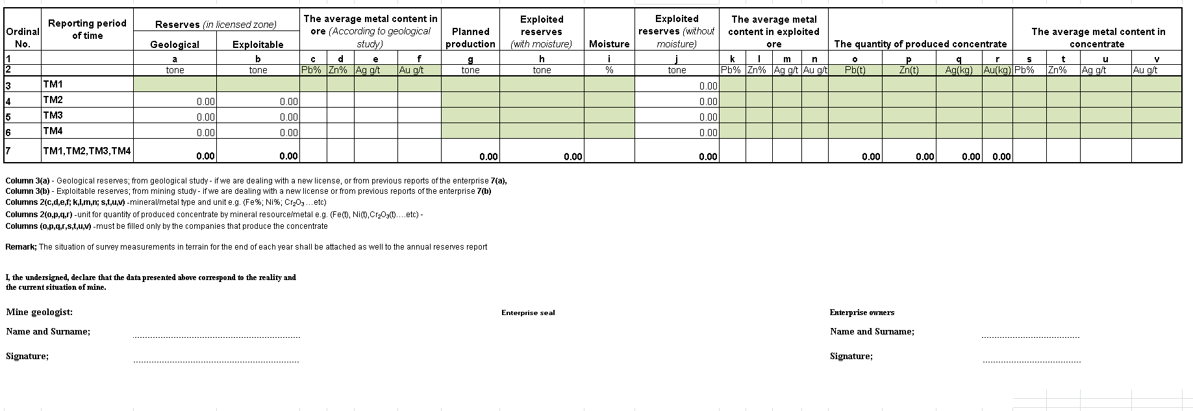

FinancE
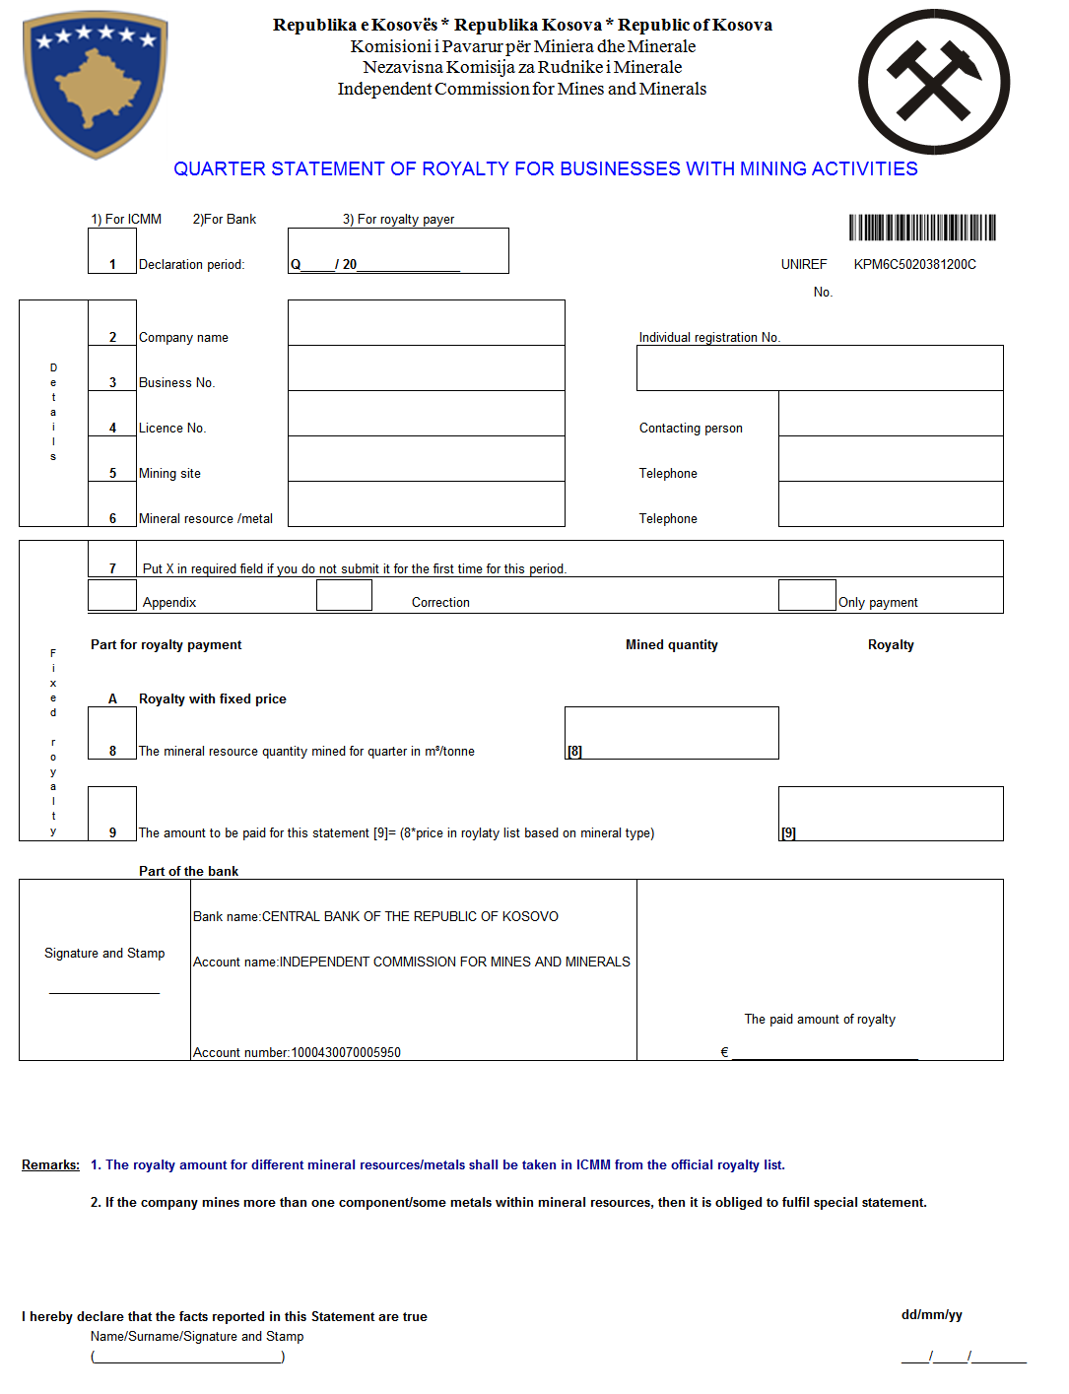

Quarter statement for minerals with royalty in %

